TRAVELLING STORY Activity
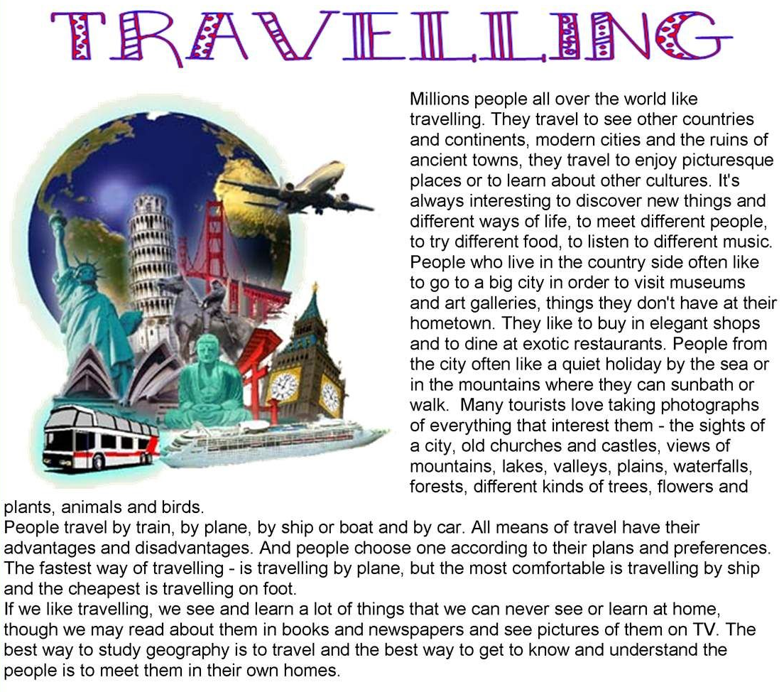

TRAVELLING Story Activity– Answering the questions
