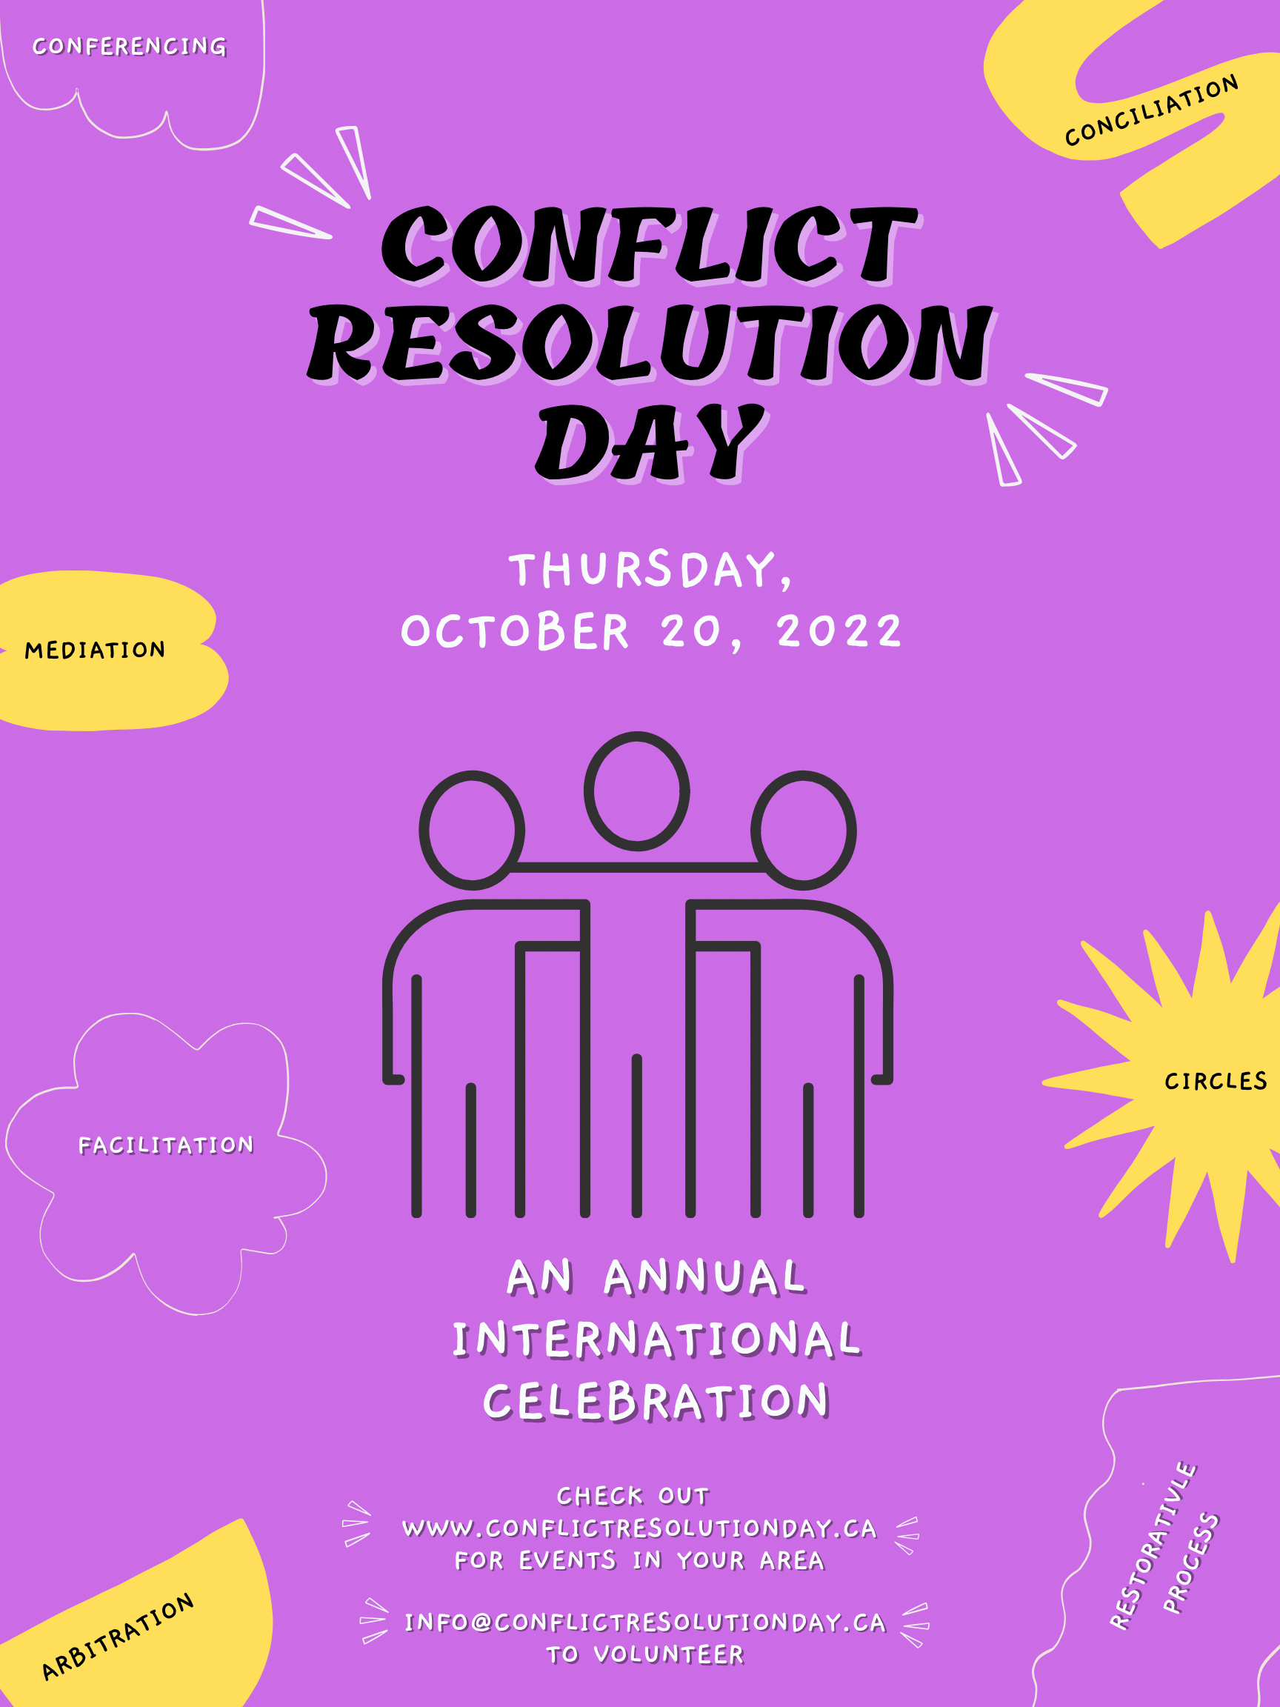
This Year’s Theme is Mind Your Own Bias!
TYPE YOUR ORGANIZATIONAL DETAILS HERE
(If you are hosting an event or otherwise to mark the day)

