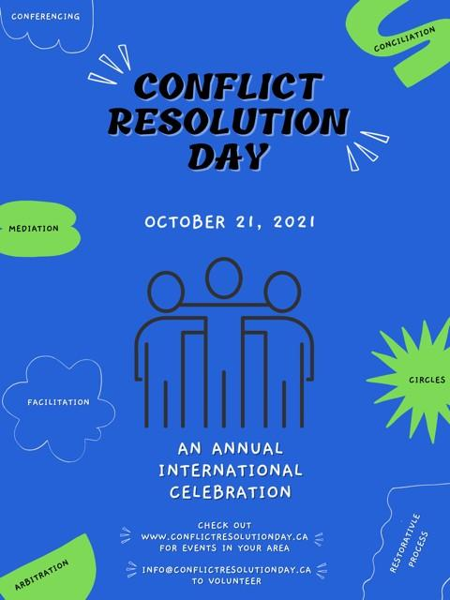
The workshop theme is:
Kindness and Communication
[Put Your Organization Name]
[Add Workshop/Event Date/Details]

