Sample Conflict Resolution Day Event Invitation

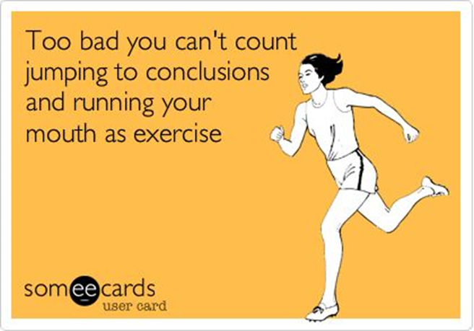

Good Morning,

Have you ever found yourself perplexed at the way someone else interpreted something you said or did, and put a meaning on it that you never intended? Perhaps you have found yourself enraged by someone’s comment or action, and concluded that they *must* be acting against you for some reason.

Quickly and unconsciously we move from what we see to a conclusion without determining if and why our conclusions may be wrong.

You do it, I do it, we all do it...at some point EVERYONE jumps to conclusions!

Help us celebrate International Conflict Resolution Day on **Thursday, October 19, 2017**, by attending a free one hour lunch and learn for <ENTER WHO IS INVITED> entitled “Why We Jump to Conclusions and How to Avoid it ”.

**WORKSHOP DETAILS**

**What:**  “Why we Jump to Conclusions and How to Avoid It”

**Where:** <ENTER LOCATION>

**When:** Thursday, October 19, 2017 <ENTER TIME>

**Why:**  To celebrate International Conflict Resolution Day, spend time with your <COLLEAGUES, COMMUNITY…> and help us all deal with things a bit more productively!!

**Instructor:** <ENTER INSTRUCTOR’S NAME OR NAMES>

**COST:** Free

**Note:** **Spaces fill up quickly - please RSVP to <ENTER EMAIL AND RSVP DUE DATE>**

Interested in learning more about Alberta Conflict Resolution Day and the Alberta Dispute Resolution Network?  Check out <http://www.conflictresolutionday.ca/> and <https://justice.alberta.ca/programs_services/mediation/drn/Pages/default.aspx>, respectively.

We hope to see you on October 19, 2017 for this fun and interactive session.



**Alberta Conflict Resolution Day**

**October 20, 2016**

[www.conflictresolutionday.ca](http://www.conflictresolutionday.ca/)

**"The one who throws the stone forgets; the one who is hit remembers forever." - Angolan Proverb**