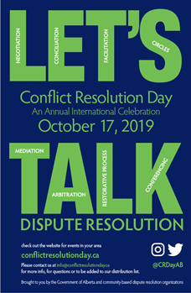
International Conflict Resolution Day October 17, 2019

Planning is well under way for the Alberta celebration of International Conflict Resolution Day on October 17th, 2019. We are asking all conflict resolution professionals who support dispute resolution practices in our province to host an event to mark the day.

You will find details about how to host an event and additional ideas on our website: http://www.conflictresolutionday.ca/2019.html. If you choose to host an event, please let us know so that we can promote your event on our website. Please provide your event details at http://www.conflictresolutionday.ca/events.html. We’ve attached a promotional poster.

Register Now for the Train-the Trainer September 19, 2019, or October 3, 2019

Learn how to facilitate this year’s Conflict Resolution Day workshop on the topic “Defusing Conflict at Work and at Home” Please contact Tara at communitymediation@sccm.ca for more information on how to register.

Week of Conflict Resolution Day activities October 14-18, 2019
- Daily TedTalks and Webinars October 14-18, 2019
- CBC Alberta at Noon “Conflict Resolution Drs. Are In”
- Info Fair at Kingsway Garden Mall on October 17
- Diffusing Conflict Presentations around Province Oct. 17
- Bridge light-up Calgary and Edmonton Oct. 17

For more information on these events and how to register, go to http://www.conflictresolutionday.ca/2019.html.

Have an event you would like publicized? Go to http://www.conflictresolutionday.ca/events.html.

Brought to you by the Alberta Conflict Resolution Day Committee

